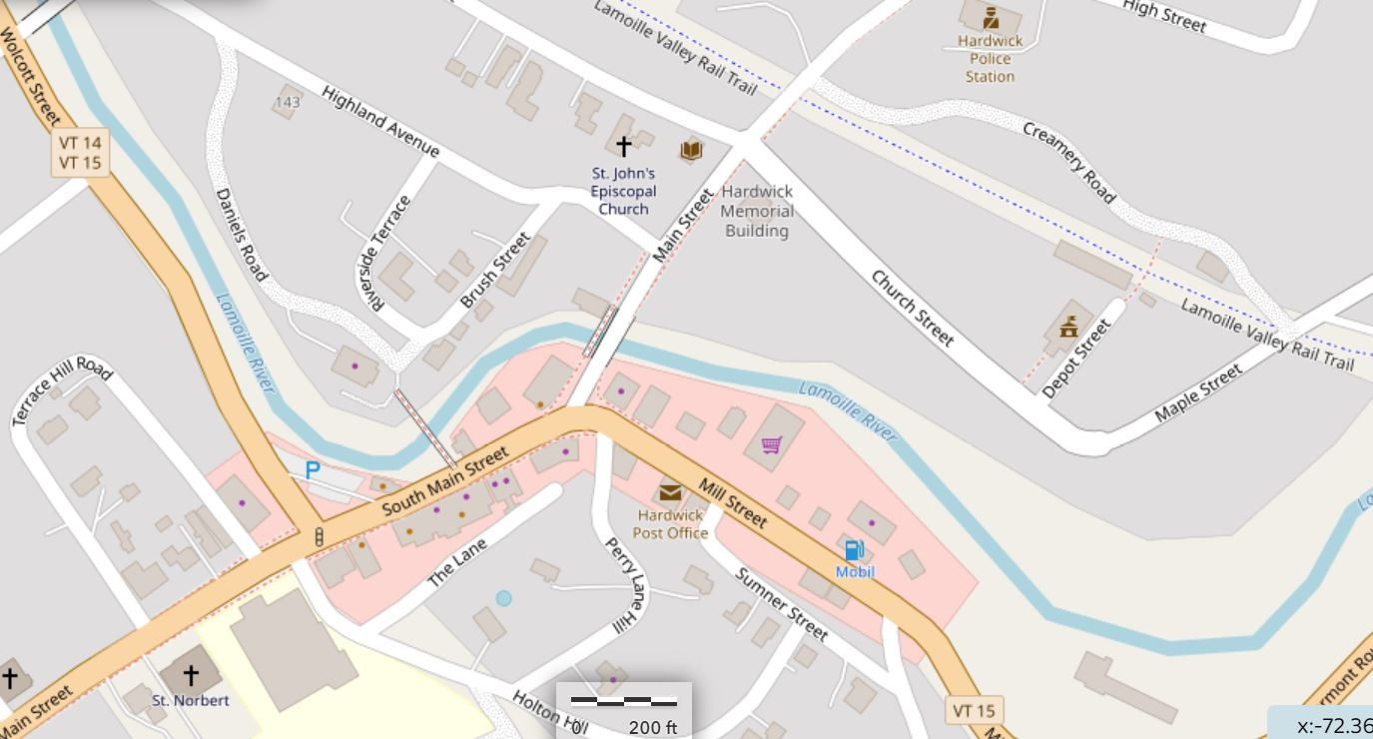
Hardwick Mill & South Main Streets Scoping Study
Study area is shaded green. Note relationship of area to downtown businesses and amenities.

